Faurecia
E-Supply System Technical Design Specification

Author: Jackey Ding

History
Version | Date | Description
1.0 | 2010-11-31 | Draft

Content

1 Solution summary 2
1.1 System Architecture 2
1.2 Technical Architecture 2
1.3 The Presentation Layer 3
1.4 The Persistence Layer 3
1.5 The Business Layer 4
1.6 The Domain Model Layer 5
2 Package DefinitioN 6
2.1 The Presentation Layer 6
2.2 The Presentation Layer 6
com.faurecia.web.struts.form 6
com.faurecia.web.struts.action 6
2.3 The Persistence Layer 7
2.4 The Business Layer 7
2.5 The Domain Model Layer 8
3 Core Classes StructurE 9
3.1 Overview 9
3.2 The Presentation Layer 10
UML Diagram 10
Core Classes 10
com.faurecia.web.struts.action.BaseAction 10
3.3 The Persistence Layer 11
UML Diagram 11
Core Classes 11
com.faurecia.dao.DAO 11
com.faurecia.dao.BaseDaoHibernate 12
3.4 The Business Layer 12
UML Diagram 12
Core Classes 13
com.faurecia.service.BaseManager 13
Implement Transaction 13
3.5 The Domain Model Layer 14
UML Diagram 14
4 Database StructurE 15
4.1 Diagram 15

1 Solution summary

2 System Architecture
The following is the system architecture for the E-Supply system, and the users can access the system via web browser, and the system will exchange the data with SAP.

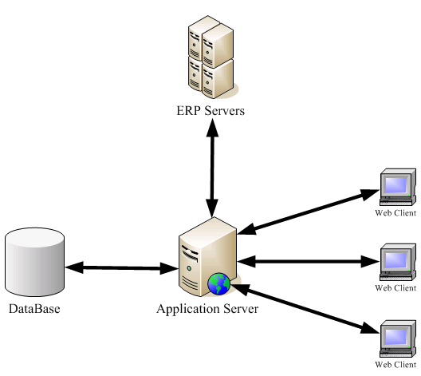

3 Technical Architecture
The system will divided into four layers of responsibility. These layers are the presentation, persistence, business, and domain model layers. Each layer has a distinct responsibility in the application and should not mix functionality with other layers. Each application layer should be isolated from other layers but allow an interface for communication between them.

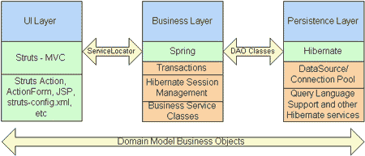

4 The Presentation Layer
We will use struts implements the presentation layer. Here is what Struts is responsible for:
- Managing requests and responses for a user.
- Providing a controller to delegate calls to business logic and other upstream processes.
- Handling exceptions from other tiers that throw exceptions to a Struts Action.
- Assembling a model that can be presented in a view.
- Performing UI validation.

Here are some items that are often coded using Struts but should not be associated with the presentation layer:
- Direct communication with the database, such as JDBC calls.
- Business logic and validation related to your application.
- Transaction management.

Introducing this type of code in the presentation layer leads to type coupling and cumbersome maintenance.

5 The Persistence Layer
At the other end of a typical web application is the persistence layer. We choose Hibernate in this layer. The Hibernate framework allows object-to-relational persistence and query service for Java. Hibernate has a medium learning curve for Java developers who are already familiar with SQL and the JDBC API. Hibernate persistent objects are based on plain-old Java objects and Java collections. The following list contains the type of code that you would write inside a persistence framework:
- Querying relational information into objects. Hibernate does this through an OO query language called HQL, or by using an expressive criteria API. HQL is very similar to SQL except you use objects instead of tables and fields instead of columns. There are some new specific HQL language elements to learn; however, they are easy to understand and well documented. HQL is a natural language to use for querying objects that require a small learning curve.
- Saving, updating, and deleting information stored in a database.
- Advanced object-to-relational mapping frameworks like Hibernate have support for most major SQL databases, and they support parent/child relationships, transactions, inheritance, and polymorphism.

Here are some items that should be avoided in the persistence layer:
- Business logic should be in a higher layer of application. Only data accress operations should be permitted.
- Should not have persistence logic coupled with presentation logic. Avoid logic in presentation components such as JSPs or servlet-based classes that communicate with data access directly. By isolating persistence logic into its own layer, the application becomes flexible to change without affecting code in other layers. For example, Hibernate could be replaced with another persistence framework or API without modification to the code in any other layer.

6 The Business Layer
The middle component of a typical web application is the business or service layer. We use Spring in this layer. All services or managers are wired together by a simple XML file that contains references to objects such as the transaction management handler, object factories, service objects that contain business logic, and data access objects (DAO).
The business layer should be responsible for the following:
- Handling application business logic and business validation
- Managing transactions
- Allowing interfaces for interaction with other layers
- Managing dependencies between business level objects
- Adding flexibility between the presentation and the persistence layer so they do not directly communicate with each other
- Exposing a context to the business layer from the presentation layer to obtain business services
- Managing implementations from the business logic to the persistence layer

7 The Domain Model Layer
The domain object layer consists of objects that represent real-world business objects. Those objects can be updated and sent back across to the persistence layer and updated within the database.

8 Package DefinitioN
A package is a collection of related classes and interfaces that provides access protection and namespace management.

We divide project into four main packages base on the four layers of responsibility. All packages are started with “com.aof” as the prefix. The four packages are “com.faurecia.dao”, “com. faurecia.service”, “com. faurecia.web.struts”, “com. faurecia.model”. Presentation layer is in the “com. faurecia.web.struts” package, business layer in the “com. faurecia.service”, persistence layer in the “com. faurecia.dao”, and domain model layer in the “com. faurecia.model” package.

9 The Presentation Layer

All presentation layer related classes all in the package “com.faurecia.web.struts”. In this package we provide the classes related to the presentation layer. Because here we use struts framework in the persistence layer in this project, so the word “struts” is in the package name.

10 The Presentation Layer

com.faurecia.web.struts.form

This is the child package of “com.faurecia.web.struts” package. This package provides the classes we call they forms for collecting the data which user submitted. One form here represents a user submitted web form.
In this package we separate five children packages base on the main processes. There are:
- com.faurecia.web.struts.form.admin ---- System administration
- com.faurecia.web.struts.form.business.pr ---- Purchase requisition process
- com.faurecia.web.struts.form.business.po ---- Purchase order process
- com.faurecia.web.struts.form.business.expense ---- Expense claim process
- com.faurecia.web.struts.form.business.ta ---- Travel application process

com.faurecia.web.struts.action

This is also the child package of “com.faurecia.web.struts” package. This package provides the classes we call they actions for managing the user requests and responses.We also separate five children packages base on the main processes. There are:
- com.faurecia.web.struts.action.admin ---- System administration
- com.faurecia.web.struts.action.business.pr ---- Purchase requisition process
- com.faurecia.web.struts.action.business.po ---- Purchase order process
- com.faurecia.web.struts.action.business.expense ---- Expense claim process
- com.faurecia.web.struts.action.business.ta ---- Travel application process

11 The Persistence Layer

All persistence layer related classes all in the package “com.faurecia.dao”. In this package we provide the classes and interfaces related to the persistence layer. The dao interfaces in the packages are presented below:
- com.faurecia.dao.admin ---- System administration
- com.faurecia.dao.business.pr ---- Purchase requisition process
- com.faurecia.dao.business.po ---- Purchase order process
- com.faurecia.dao.business.expense ---- Expense claim process
- com.faurecia.dao.business.ta ---- Travel application process

And there hibernate implementations are in the packages below:
- com.faurecia.dao.admin.hibernate ---- System administration
- com.faurecia.dao.business.pr.hibernate ---- Purchase requisition process
- com.faurecia.dao.business.po.hibernate ---- Purchase order process
- com.faurecia.dao.business.expense.hibernate ---- Expense claim process
- com.faurecia.dao.business.ta.hibernate ---- Travel application process

12 The Business Layer

All business layer related classes all in the package “com.faurecia.service”. In this package we provide the classes and interfaces related to the business layer. Base on the thinking of Interface-Oriented Design, we design interface for each service or manage.
And implement them later. You can find interface in these packages below.
- com.faurecia.service.admin ---- System administration
- com.faurecia.service.business.pr ---- Purchase requisition process
- com.faurecia.service.business.po ---- Purchase order process
- com.faurecia.service.business.expense ---- Expense claim process
- com.faurecia.service.business.ta ---- Travel application process

And there implementations are in the packages below:
- com.faurecia.service.admin.impl ---- System administration
- com.faurecia.service.business.pr.impl ---- Purchase requisition process
- com.faurecia.service.business.po.impl ---- Purchase order process
- com.faurecia.service.business.expense.impl ---- Expense claim process
- com.faurecia.service.business.ta.impl ---- Travel application process

13 The Domain Model Layer

All domain model layer related classes all in the package “com.faurecia.model”. In this package we provide the classes related to the domain model layer. The children package structure is presented below:
- com.faurecia.model.admin ---- System administration
- com.faurecia.model.business.pr ---- Purchase requisition process
- com.faurecia.model.business.po ---- Purchase order process
- com.faurecia.model.business.expense ---- Expense claim process
- com.faurecia.model.business.ta ---- Travel application process

14 Core Classes StructurE

15 Overview

The picture below gives an overview of the system core classes and general implementation for one module.

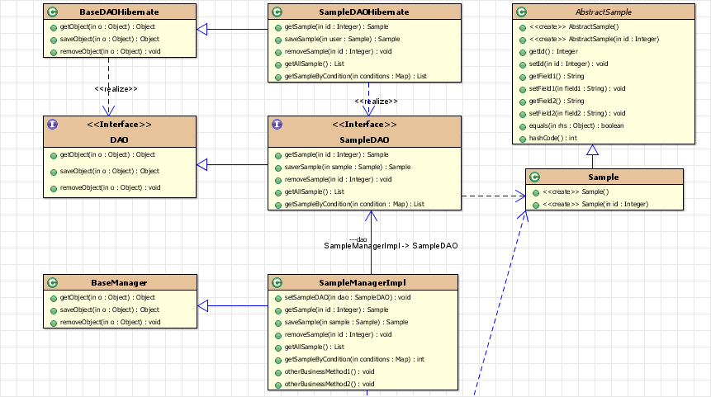
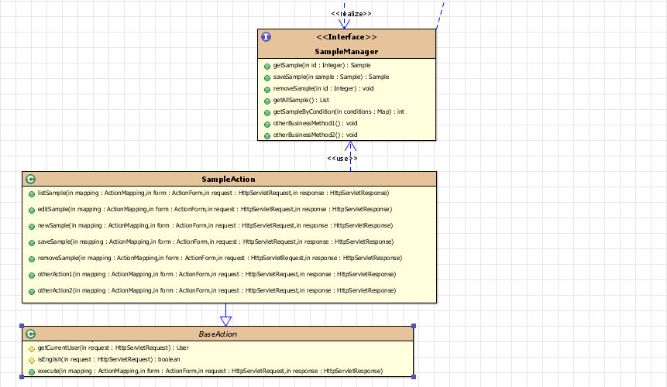

16 The Presentation Layer

UML Diagram

Follow picture shows the core class and general implementation of the presentation layer.

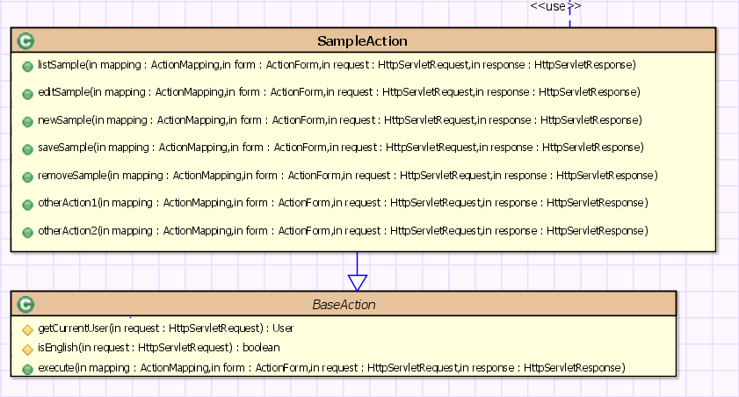

Core Classes

com.faurecia.web.struts.action.BaseAction

The class implements org.apache.struts.action.Action that contains base methods for Actions as well as determines with methods to call in subclasses. The central presentation layer concept is this action. The action is a controller component that is similar to a servlet in that it is a reusable, thread-safe object that is passed HttpServletRequest and HttpServletResponse objects in its central workflow method “execute”.

Main Methods Introduction:
- getCurrentUser method -- Convenience method to get the current user from the session
- isEnglish method -- Decide user interface language using English or second language.
- execute method -- Override the execute method in org.apache.struts.action.Action to parse URLs and forward to methods without parameters.

17 The Persistence Layer

UML Diagram

Follow picture shows the core class and general implementation of the persistence layer.

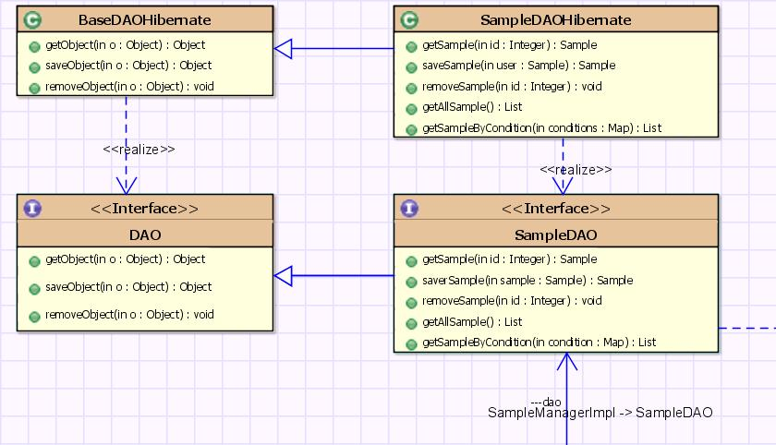

Core Classes

com.faurecia.dao.DAO

This is a Data Access Object (DAO) interface. This is an interface used to tag our DAO classes and to provide common methods to all DAOs.

Main Methods Introduction:
- getObject -- Generic method to get an object based on class and identifier. An ObjectRetrievalFailureException Runtime Exception is thrown if nothing is found.
- saveObject -- Generic method to save an object - handles both update and insert.
- removeObject -- Generic method to delete an object based on class and id

com.faurecia.dao.BaseDaoHibernate

We uses hibernate for its default implementation of persistence layer. Hibernate is an Object/Relational (O/R) Framework that allows you to relate your Java Objects to database tables. It allows you to very easily perform CRUD (Create, Retrieve, Update, Delete) on your objects
And this class implements the interface com.faurecia.dao.DAO. This class serves as the Base class for all other DAOs - namely to hold common methods that they might all use. Can be used for standard CRUD operations.

Main Methods Introduction:
- Generic method to get an object based on class and identifier. An ObjectRetrievalFailureException Runtime Exception is thrown if nothing is found.
- saveObject -- Generic method to save an object - handles both update and insert.
- removeObject -- Generic method to delete an object based on class and id

18 The Business Layer

UML Diagram

Follow picture shows the core class and general implementation of the business layer.

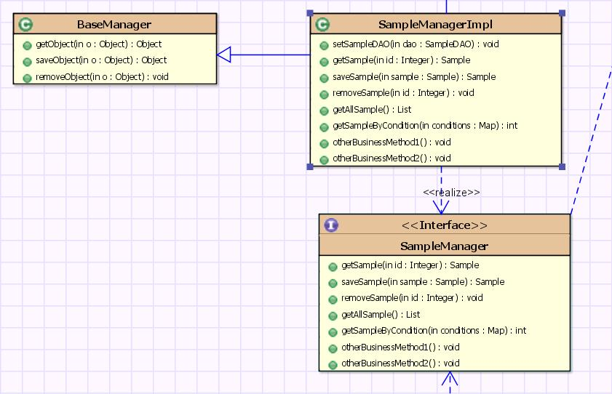

Core Classes

com.faurecia.service.BaseManager

Base class for Business Services - use this class for utility methods and generic CRUD methods.
Its main responsibility is to act as a bridge between the persistence (DAO) layer and the presentation layer. It's also useful for de-coupling presentation layer from your database layer. Managers should also be where put any business logic for application.

Main Methods Introduction:
- getObject -- Generic method to get an object based on class and identifier.
- saveObject -- Generic method to save an object.
- removeObject -- Generic method to delete an object based on class and id

Implement Transaction

It’s simple to declare transaction for business manager. You don’t need write a piece of code in the class, just define the transaction in the applicationContext-service.xml. Picture below illustrate about how to define the transaction for a manager.

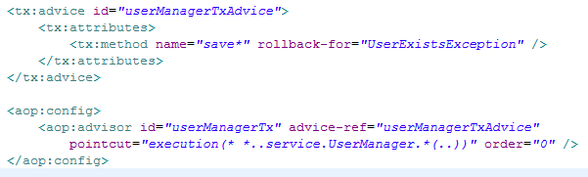

19 The Domain Model Layer

UML Diagram

Follow picture shows the sample model object for the Domain Model layer.

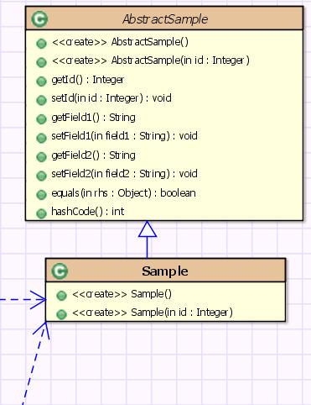

In this layer, we will create an object and then some more classes to persist that object from the database. This object basically represents a database table.

20 Database StructurE

21 Diagram
